**Exp No: 6 Date: 28/08/2024**

**PUBLIC CLOUD**

**CREATING AN INSTANCE IN MICROSOFT AZURE**

**AIM:**

Develop a simple application to understand the concept of PAAS using Microsoft Azure.

**PROCEDURE:**

1. Sign in to the Azure portal
2. Select Azure SQL on the left menu of the Azure portal.
3. Select +Add to open the Select SQL deployment option page.
4. Select Create.

**OUTPUT:**

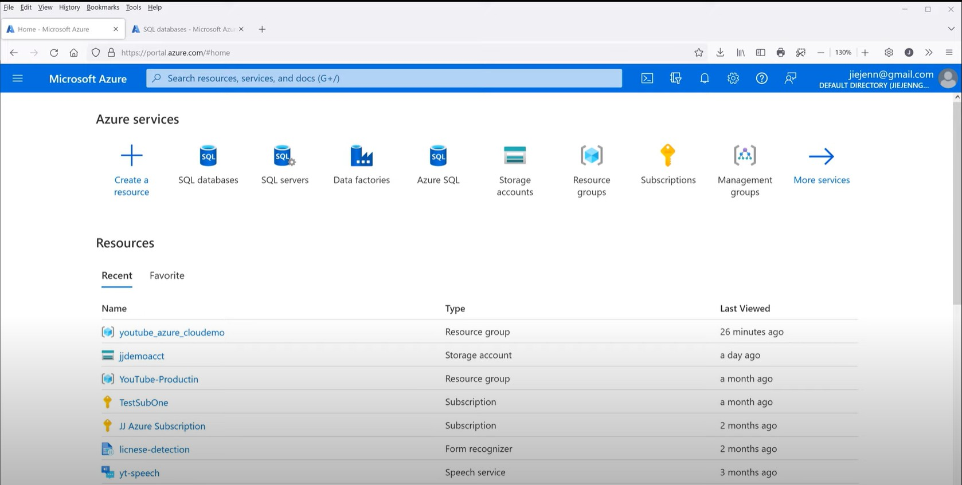

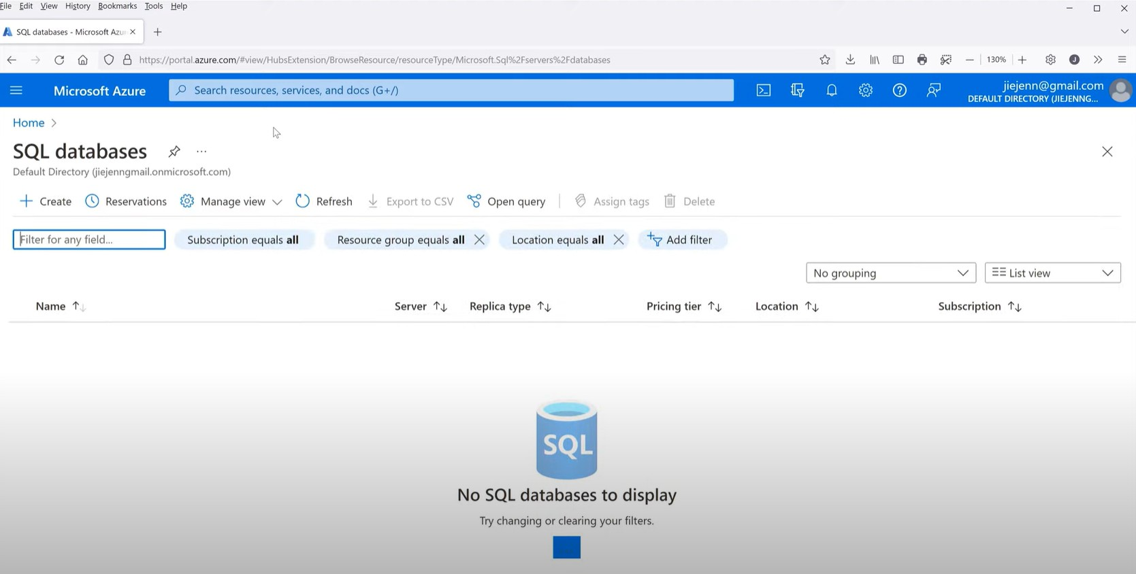

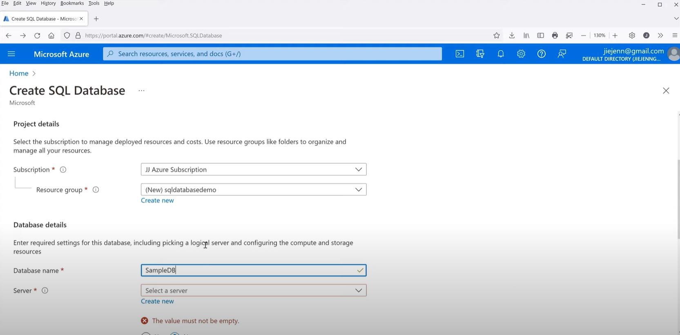

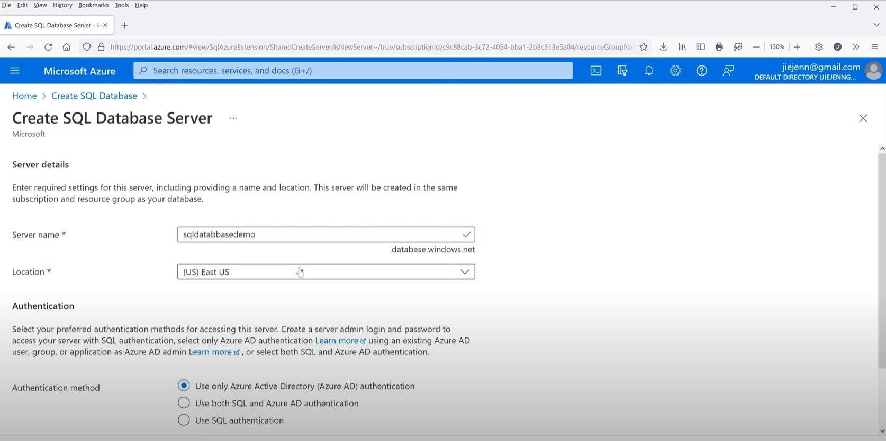

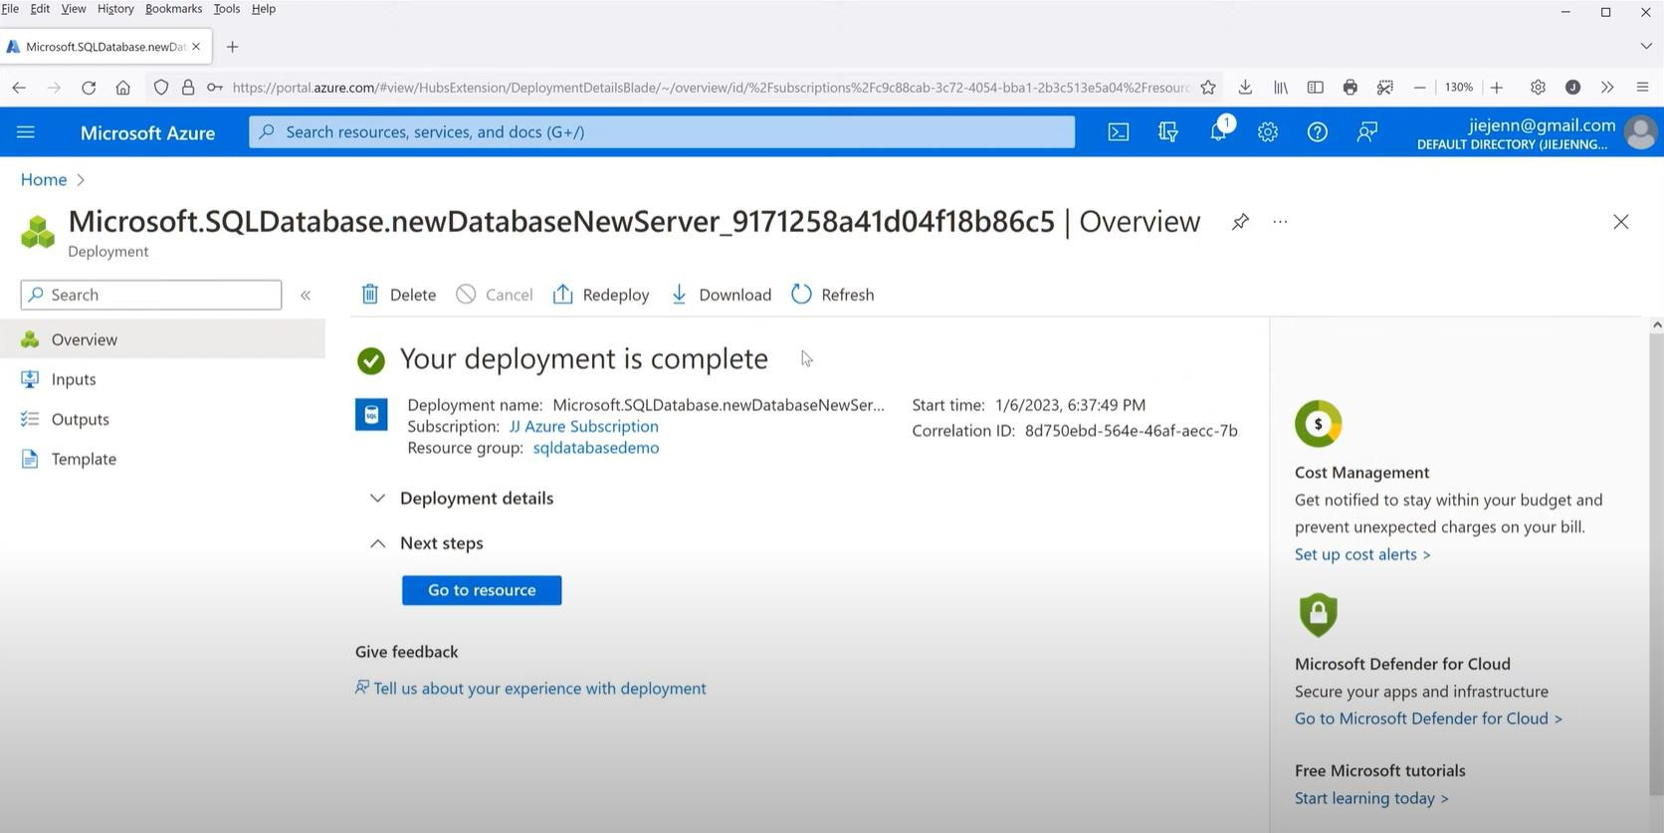

**RESULT:**

A simple application is to understand the concept of PAAS is successfully implemented using Microsoft Azure.